THERMATEST Model TCFCM Comparative Instrument
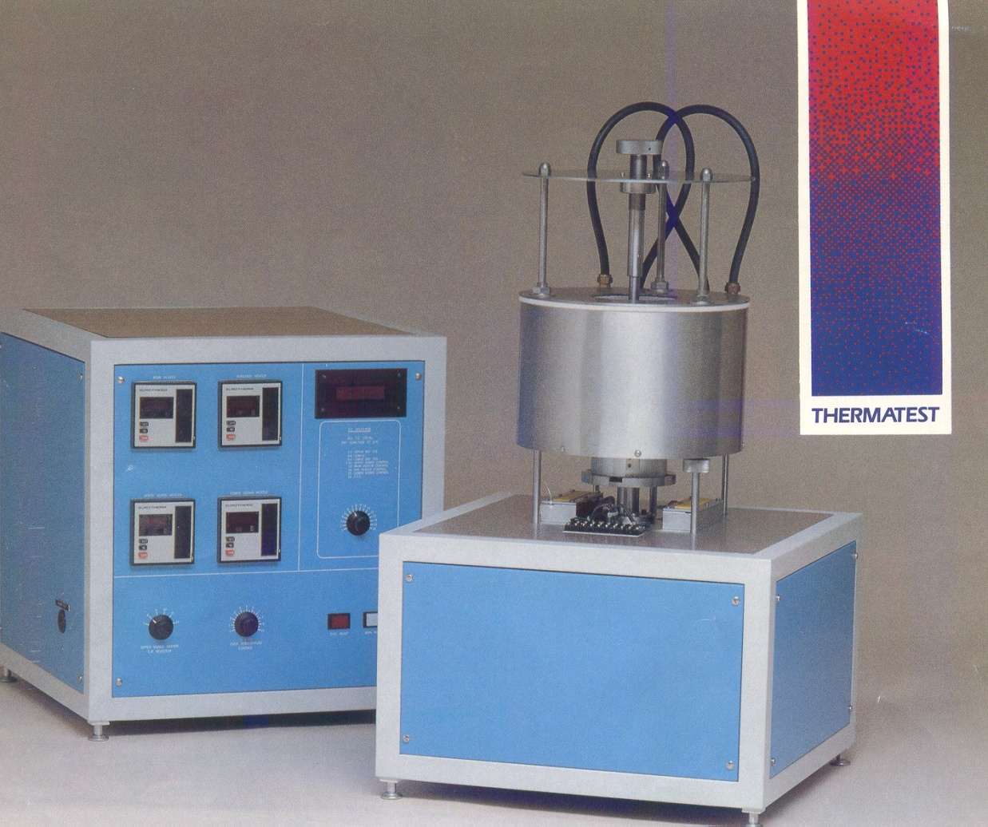
Thermal conductivity-the rate of heat flow through a substance-has become a parameter of critical importance in many fields and applications. In materials development for electronics packaging applications, for example, the ability of a material to conduct heat is the governing factor in determining its performance.
The Model TCFCM comparative instrument is a convenient, flexible system which mesures the thermal conductivity of a variety of solid materials over a broad range of temperatures and environmental conditions. Materials wich can be tested in the model TCFCM-N20, include ceramics, composites, metals, metals alloys, filled plastics and epoxies, geological materials, and carbon products.
This instruments an excellent research tool for evaluating materials in the moderate-to high conductivity range of 0.2 to 100 W/m K. Standard sample sizes are 25 or 50mm in diameter and 12 to 38mm thick. Test can be performed over a temperatures range of -150ºC to +1000ºC, either in air or inert gas environments. Liquid nitrogen must be used to allow operation at cryogenic temperatures.

The comparative technique utilizes known propieties of standard reference materials to measure heat flow. The test specimen is sandwiched between two identical reference samples. This stack is placed beetween two heating elements, controlled at different temperatures. The resultant flow of heat through the composite stack produces a temperature distribution wich is measured with termocouples. At thermal equilibrium, thermal conductivity of the test specimen can then be computed.
This instrument is designed to archieve test accuracies between +-5% to+-10% over the entire thermal conductivity range. An important factor in estimating the overall test accuracy is the extent to wich the thermal conductance of the test sample matches that of the reference material . Several types of reference materials are offered wich cover different segments of thermal conductivity range, including pyrex 7740, pyroceram 9606, inconel 718, and electrolytic iron.
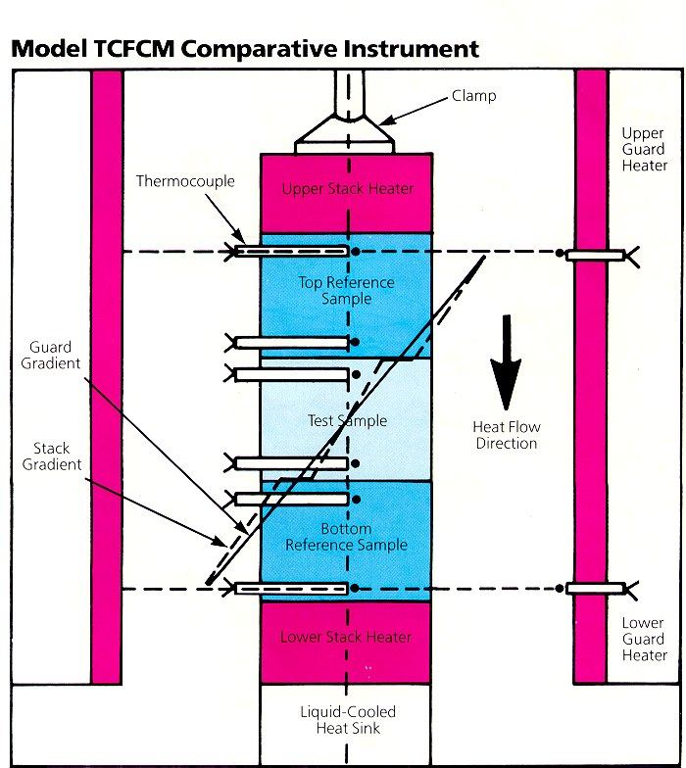
A cylindrical linear gradient guard heater is placed around the samples to ensure that the heat flux through the stack is constant .The top and bottom temperatures of the guard heater are controlled at the same set points as the corresponding heaters in the stack, thus producing an axial gradient in the guard heater to that in the test stack. Temperatures along the length of the guard heater can be measured to verify proper control.

Specifications- Model TCFCM

Test Method | Comparative Thermal Conductivity
Standard Sample Sizes | 50 mm diameter  25mm diameter  12 a 38 mm Thick
Temperature Range | -150ºC a +1000ºC
Sample Environment | Air, inert gas
Accuracy | ±5% a ±10%
Reproducibility | ±3%
Temperature Sensors | Chromel/Alumel Thermocouples
Heat Sink Coolant | T > 100ºC: city water  T<100ºC : Opcional circulator or LN₂

Services:
To mesure thermal conductivity of ceramics, composites, metals, metals alloys, filled plastics and epoxies, geological materials, and carbon products.
Contact :
M.Núria Vives
Tel.+ 34 93 401 59 00
Fax+34 93 401 73 89
e-mail: nvives@mmt.upc.edu
Adress:
Unidat de Termotècnia
Escola Técnica Superior d’Ingeniería Industrial de Barcelona
(Universidat Politécnica de Catalunya)
Avinguda diagonal nº 647
08028 Barcelona
Spain

